Modelling Ambient Populations under Different Restriction Schemes

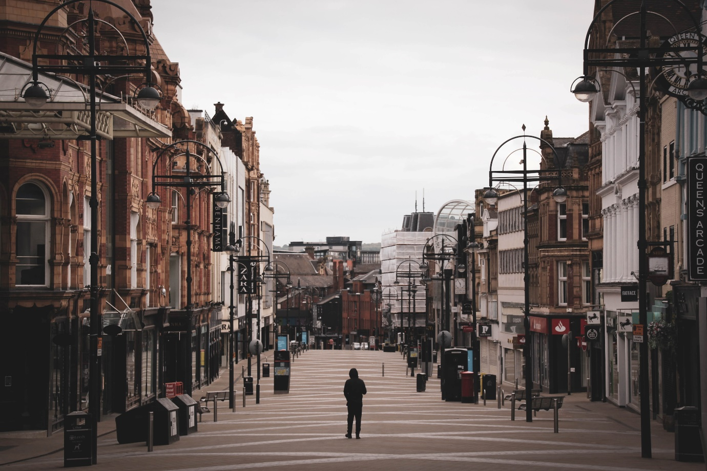

Photo by [Gary Butterfield](https://unsplash.com/es/@garybpt?utm_source=unsplash&utm_medium=referral&utm_content=creditCopyText) on [Unsplash](https://unsplash.com/s/photos/leeds?utm_source=unsplash&utm_medium=referral&utm_content=creditCopyText)

The COVID-19 pandemic has had a huge impact on urban mobility, leading to two major questions, namely:

1. How have cities changed during the pandemic?
2. Which changes will remain as the pandemic subsides?

To help answer these questions, this project will build on previous CDRC-funded work (i.e. the [Leeds City Council Ambient Pop under COVID-19](https://lida.leeds.ac.uk/research-projects/5037-2/) project) to create an open source spatial-temporal machine-learning model to predict overall change in footfall, as well as the heterogeneous impacts that restrictions will have on different local areas around Leeds. It will consider the local urban configuration, external factors (like weather conditions) and, importantly, the impact of various mobility restriction measures. The model will be first trained using footfall data from the CDRC (SmartStreetSensors) and from Leeds City Council (footfall cameras) from the years before the pandemic. Lockdown restriction conditions will be incorporated thereafter.

The project partners, Leeds City Council, have a particular interest in better estimating how footfall in city-centre will vary as the pandemic, and related policies, subsides. A suitable dashboard will also developed to present maps and related visual outputs to help the policy makers to easily explore different scenarios. Although based on Leeds, it is expected that the work will be generalisable to other cities that have footfall estimates and could even be applied even where footfall data do not exist.

Ultimately, we aspire to attract further funding to construct a nationwide footfall model, which would represent an attractive CDRC outcome as a great methodological advance as well as a contribution to furthering the improvements in public health, urban development etc.